Exp.No:38
38. Face Detection using OpenCV.

Aim:
To detect human faces in an image using the Haar Cascade Classifier in OpenCV.
Procedure:
- Read the input image.
- Convert it to grayscale.
- Load the Haar Cascade face detector.
- Detect faces using detect Multiscale().
- Draw rectangles around detected faces.
- Display and save the output.
Program:
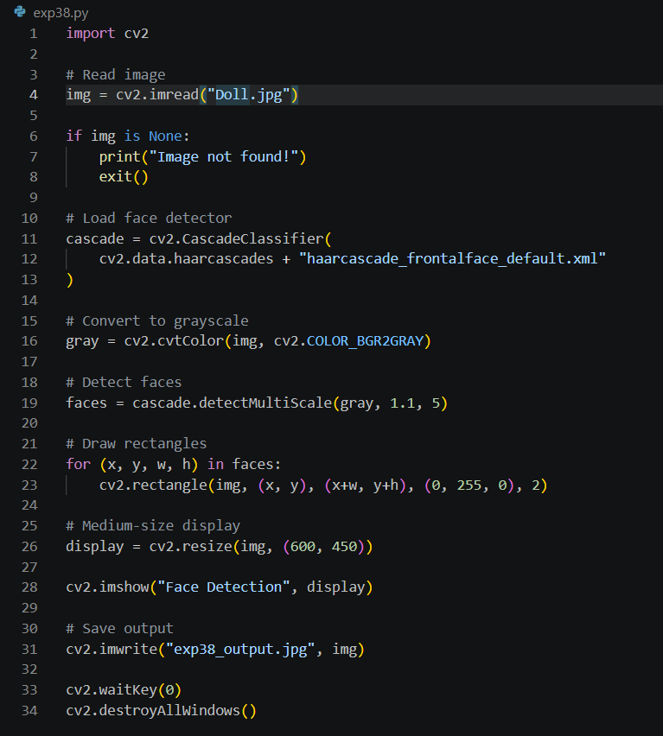

Input:


Output:

Result:
The faces in the given image were successfully detected using OpenCV.

